# **Name: Abdurrahman Qureshi**

# **Roll No: 242466**

Practical No: 1

1) Write a program to demonstrate inheritance

CODE:

#include "iostream"

using namespace std;

class Parent{

public:

    void displayParent(){

        cout << "From Daddy" << endl;

    }

};

class Child : public Parent{

public:

    void displayChild(){

        cout << "From Boomer" << endl;

    }

};

int main(){

    Child child;

    child.displayParent();

    child.displayChild();

    return 0;

}

**OUTPUT:**

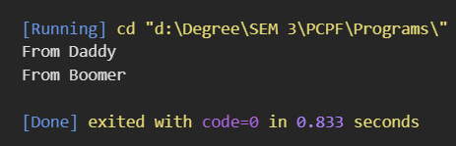

2) Write a program to demonstrate Encapsulation

CODE:

#include "iostream"

#include "string"

using namespace std;

class Character{

private:

    string name;

public:

    void getName(string n){

        name = n;

    }

    void printName(){

        cout << "Name: " << name << endl;

    }

};

int main(){

    Character p;

    p.getName("Arthur Morgan");

    p.printName();

    return 0;

}

**OUTPUT:**

